Week 1 Report
Data Collection and Preliminary Analysis in Supply Chain Management
Supply Chain Analytics Internship
Prepared by: [Tushar Charavande]
Date: September 2026

1. Introduction and Objective
Supply chains depend on good data. Decisions about where to hold stock, which ports or routes to use, and how much capacity to plan for are only as good as the information behind them. The objective of this Week 1 task is to practise the fundamentals of data collection and preliminary analysis in a supply chain context, using only publicly available data.
This report identifies four public data sources covering logistics performance, inventory management and transportation. It explains why each source was selected, how the data was collected and filtered, how its quality was assessed, and what an initial exploratory analysis reveals. It closes with the challenges met and areas that deserve deeper investigation in later weeks.

2. Research: Data Sources Identified
Four sources were shortlisted and used. Together they cover the three themes named in the task: logistics, inventory management and transportation.
Source | Publisher | Theme | Data used
Logistics Performance Index (LPI) 2023 | World Bank | Logistics | Overall country scores (scale 1 to 5) and six component scores; container dwell times
Total Business: Inventories to Sales Ratio (ISRATIO / TOTBUSIRNSA) | US Census Bureau, via FRED (St. Louis Fed) | Inventory management | Monthly ratio of end-of-month inventory to monthly sales, 1992 onward
Review of Maritime Transport 2025 | UNCTAD | Transportation | Global seaborne trade volume (million tons), growth rates and ton-miles
LPI 2.0 (2025 edition) | World Bank | Logistics (context) | Shipment-tracking based indicators for 2023-24; used to understand how the LPI methodology is changing

3. Selection of Sources and Filtering Criteria

3.1 Why these sources
- Public and free: all four can be opened without an account, licence fee or company login.
- Authoritative publishers: the World Bank, the US Census Bureau (through the Federal Reserve Bank of St. Louis) and UNCTAD are official institutions with documented methods.
- Complementary coverage: the LPI compares countries, the inventory ratio tracks business behaviour over time, and the UNCTAD report tracks physical movement of goods. One source alone would give a narrow picture.
- Well documented: each source explains its definitions, so figures can be interpreted correctly.

3.2 Criteria used to filter the data
- Relevance: only indicators that relate directly to logistics performance, inventory levels or freight movement were kept.
- Recency: the latest available edition or period was preferred (LPI 2023, UNCTAD 2025 for 2024 data, FRED data up to early 2026).
- Comparability: for country comparisons only the overall LPI score on the common 1 to 5 scale was used, and a small set of countries was chosen to represent leaders (Singapore, Finland, Germany), large economies (USA, China, UK) and India.
- Consistency of series: seasonally adjusted and non-seasonally adjusted figures were never mixed in the same chart.
- Traceability: only figures that could be tied to a named publisher and edition were included.

4. Data Collection Method
Data was gathered manually from the public web pages and reports of the publishers listed above. The steps were:
- Search for candidate datasets using keywords such as logistics performance index, inventories to sales ratio and seaborne trade volume.
- Open the official publisher page (lpi.worldbank.org, fred.stlouisfed.org, unctad.org) to confirm the definition, units, coverage period and update frequency.
- Record the values needed for the analysis in a working table, noting the source and edition beside each value.
- Cross-check headline figures against at least one secondary report or news summary of the same publication.
- Build the charts and tables from the recorded values.
No private, internal or paid resources were used. No company data was accessed at any stage. The FRED series is marked public domain with citation requested, and this report cites all sources in the reference list.

5. Data Quality and Relevance
Source | Strengths | Limitations
LPI 2023 | Covers 139 countries; six clear components; widely used benchmark | Based partly on a perception survey of logistics professionals; the previous edition was 2018, so there was a five-year gap; methodology changed in 2023, limiting comparison with older editions
FRED inventory-to-sales ratio | Long monthly history from 1992; official Census Bureau survey; regularly updated | Covers the US only; data is subject to revision; non-seasonally adjusted values swing month to month (for example 1.28 in December 2025 versus 1.46 in January 2026)
UNCTAD Review of Maritime Transport 2025 | Global coverage; combines volume and distance-adjusted (ton-mile) measures | Covers sea freight only; 2025 figures are forecasts, not actuals; full datasets sit in a separate statistics portal
Container dwell time (World Bank, 2022) | Direct operational measure of port efficiency | Covers a short window (May to October 2022) and a limited number of countries

Overall, the sources are reliable for identifying broad patterns. They are less suited to precise forecasting, because they are aggregated at country or national level and use different time periods.

6. Preliminary Analysis

6.1 Logistics performance across countries (LPI 2023)
Singapore leads the 2023 LPI with 4.3, followed by Finland at 4.2. Germany, the Netherlands, Switzerland and Denmark share 4.1. The United States scores 3.8, China and the United Kingdom 3.7, and India 3.4. Figure 1 compares a selected group of countries.
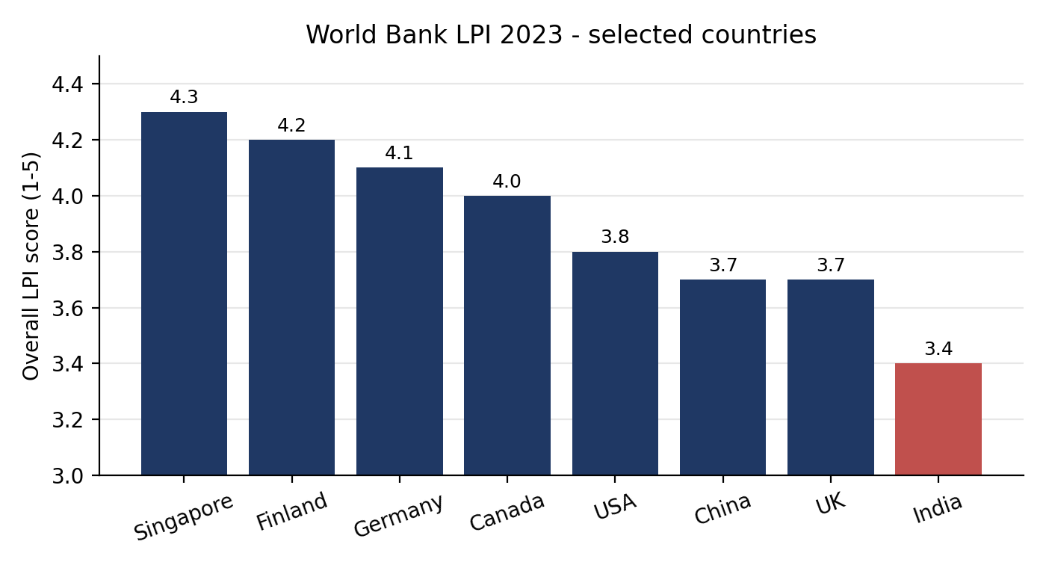
Figure 1: Overall LPI 2023 scores for selected countries (source: World Bank)
Summary measure (8 selected countries) | Value | Note
Highest score | 4.3 (Singapore) | Top of the global ranking
Lowest score in the group | 3.4 (India) | Lowest of the selected countries
Range | 0.9 points | Spread on a 1 to 5 scale
Mean | 3.90 | Simple average of the eight scores

6.2 Port efficiency: container dwell time
Dwell time, the number of days a container waits at a port, helps explain why some countries score higher. Between May and October 2022, the average dwell time was 3 days in India and Singapore, 4 days in the UAE and South Africa, 7 days in the United States and 10 days in Germany.
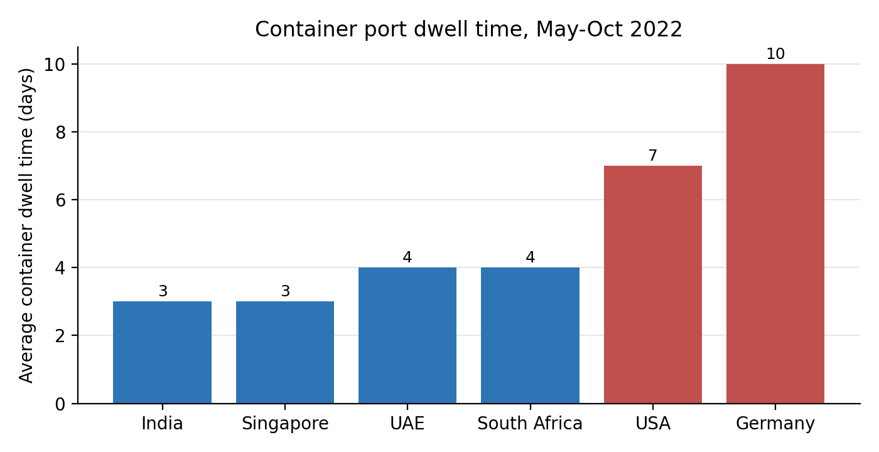
Figure 2: Average container dwell time in days, May to October 2022 (source: World Bank)
Germany scores 4.1 on the LPI but had the longest dwell time in this sample, while India scores lower overall but had one of the shortest dwell times. This shows that a single composite score can hide differences between individual parts of the supply chain.

6.3 Inventory management: US inventories-to-sales ratio
The ratio shows how many months of sales are covered by stock on hand. On the seasonally adjusted series it reached a record high of 1.74 in April 2020, when sales collapsed at the start of the pandemic while stock was still in the system, and a record low of 1.24 in March 2011. The non-seasonally adjusted series for recent months is shown in Figure 3.
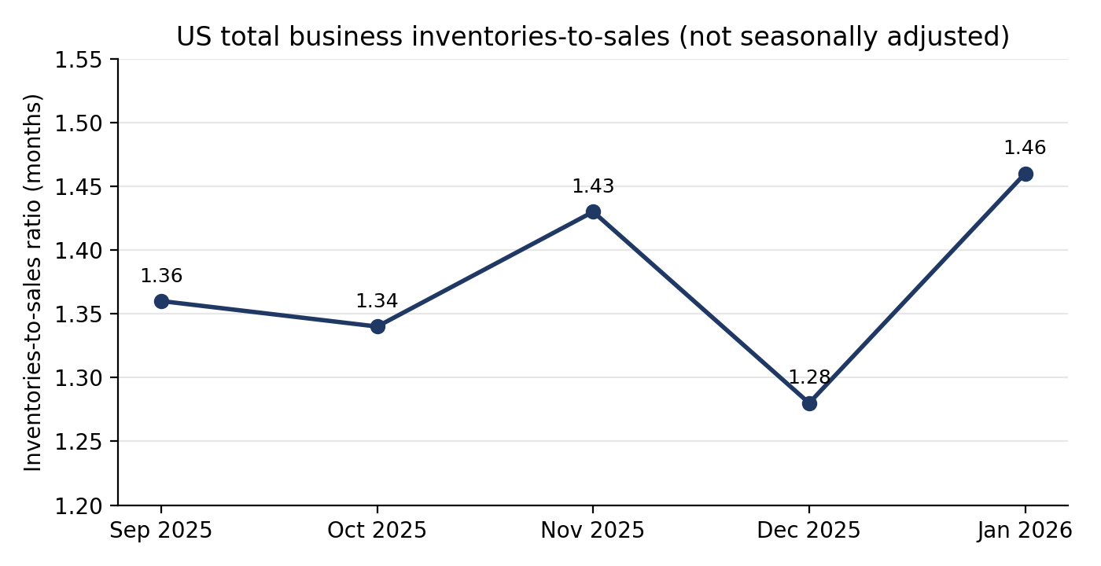
Figure 3: US total business inventories-to-sales ratio, Sep 2025 to Jan 2026, not seasonally adjusted (source: US Census Bureau via FRED)
Month | Ratio | Comment
Sep 2025 | 1.36
Oct 2025 | 1.34
Nov 2025 | 1.43 | Higher stock ahead of the holiday season
Dec 2025 | 1.28 | Lowest of the five months
Jan 2026 | 1.46 | Highest of the five months

Across these five months the ratio ranges from 1.28 to 1.46, an average of about 1.37 months of cover. The comment on November is an interpretation and should be tested against a longer seasonal history in later analysis.

6.4 Transportation: global seaborne trade
UNCTAD reports that maritime trade volumes reached 12,720 million tons in 2024, growing 2.2 per cent, which is above the 2013 to 2023 average of 1.8 per cent but below the 2003 to 2023 average of 2.9 per cent. Ton-miles, which account for distance travelled, grew 5.9 per cent in 2024 because ships were rerouted over longer distances. Growth is forecast to slow to only 0.5 per cent in 2025.
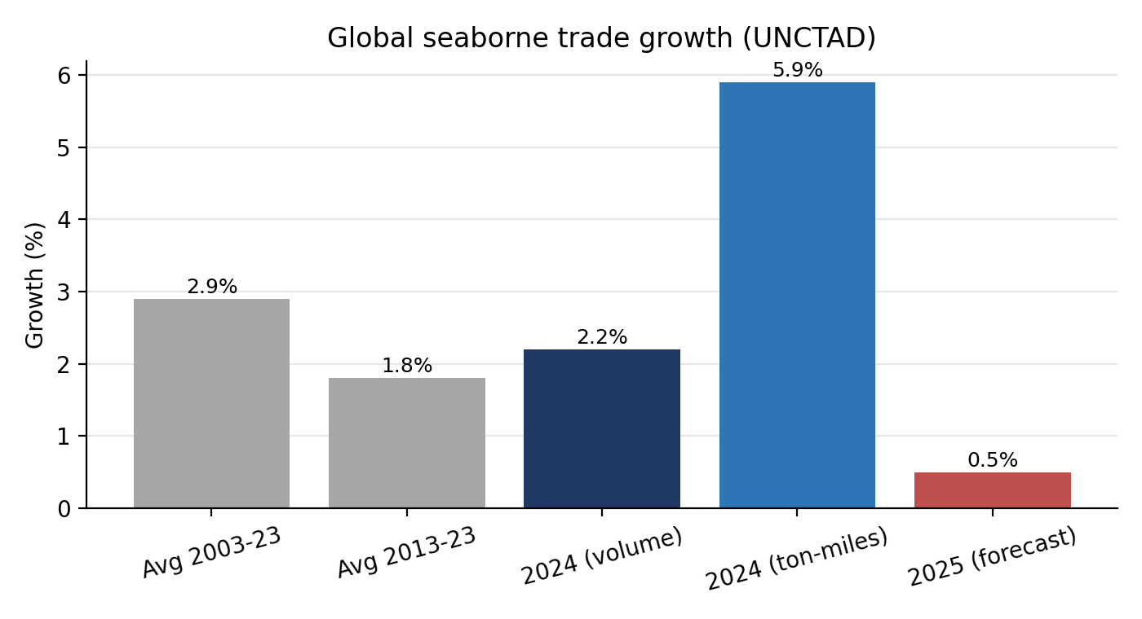
Figure 4: Global seaborne trade growth rates (source: UNCTAD Review of Maritime Transport 2025)

7. Key Observations and Trends
- High-income, mostly European economies dominate the top of the LPI. Singapore is first, and eight of the top twelve countries are European.
- A country's overall logistics score does not always match its performance on individual measures such as dwell time.
- Inventory levels react strongly to shocks. The April 2020 spike in the inventories-to-sales ratio shows how quickly a demand shock can push stock cover far above normal.
- Seaborne trade volume growth is slowing over the long term, while distance-adjusted growth was much higher in 2024. Rerouting means the same cargo needs more ship capacity, which raises cost and time.
- Sources use different time periods (2022, 2024, 2026), so they can be compared for themes but not merged into one dataset.

8. Challenges Encountered
- Different formats and time periods: the sources differ in units, frequency and years, so direct comparison was not possible.
- Methodology change: the World Bank has moved from the survey-based LPI to a data-driven LPI 2.0, so newer and older editions should not be treated as one continuous series.
- Separating seasonally adjusted from non-seasonally adjusted data required care to avoid misleading charts.
- Full datasets are sometimes behind download portals, so a selection of headline figures was recorded instead of complete tables.
- Public data is aggregated. It cannot show how an individual company's supply chain performs.

9. Areas for Further Investigation
- Download the full LPI 2023 dataset and compare all six components for India against the leaders to identify which component drives the gap.
- Download the full monthly ISRATIO history from FRED and analyse seasonality, and compare the pandemic period against normal years.
- Use the UNCTAD maritime statistics portal to study container trade by route and link it to dwell times and port performance.
- Explore whether countries with shorter dwell times also show lower logistics costs or faster customs clearance.
- Explore the LPI 2.0 shipment-level indicators for 2023-24 and compare them with the earlier survey-based scores.

10. Tools and Process
Public web sources were reviewed and key values were recorded in a working table. Charts were produced with Python (matplotlib). The report was compiled as a Word document. Charts and tables can be reproduced in Excel by entering the same values from the sources listed below.

11. Conclusion
This exercise showed that useful supply chain insight can be built from public data alone. The LPI shows how countries compare on logistics, the inventories-to-sales ratio shows how businesses manage stock through shocks, and the UNCTAD data shows how physical trade flows are changing. The main lesson is that data source, time period and method matter as much as the numbers themselves. Careful documentation of where the data came from, and of its limits, is what makes a preliminary analysis trustworthy.

References
- World Bank. Logistics Performance Index (LPI) 2023 and LPI 2.0. https://lpi.worldbank.org
- US Census Bureau via FRED, Federal Reserve Bank of St. Louis. Total Business: Inventories to Sales Ratio (ISRATIO, TOTBUSIRNSA). https://fred.stlouisfed.org/series/ISRATIO
- UNCTAD. Review of Maritime Transport 2025: Staying the course in turbulent waters. https://unctad.org
- Upply Market Insights. Logistics Performance Index: 5 key figures (June 2023), for container dwell time data.
- Trading Economics. United States Total Business Inventories to Sales, for historical record high and low.

